|  |  |
| --- | --- |
| **Full name of student** | Muhammad Afzal Ismail |
| **Student ID number** | 170061238 |
| **Date of meeting (Time/Room)** | 05/03/19 11.30a.m  G12 |
| **Date of previous meeting** | 26/02/19 |

**Meeting Agenda:**

|  |
| --- |
| 1. Discuss mid-project presentation 2. Discuss progress of project |

**Action Item/s from the previous meeting**

|  |
| --- |
| 1. Display table according to the headers selected by the user in the UI. 2. Display statistical information according to the whole dataset and for each particular data column selected by the user. 3. Research on RStudio and tableau. 4. Make automated unit testing, using Junit, for the statistical functions, such as mean, max, min, etc. |

**Matters Arising from the Minutes**

|  |
| --- |
| 1. Demonstrated the current progress state of the project. The program can now display the columns selected by the user (refer Appendix A Figure 1). 2. Mentioned the issues encountered to display the data as originally the plan was to use the tableview library in JavaFX. However, after doing research on that topic, this library can only be used to display the data from a specific object created by the program. In this case, the data is being read from .csv files and retrieved from arraylists, so no object is being created. 3. Demonstrated how the list of data is being displayed using JavaFX. Each column of data is displayed in its own gridbox. 4. Discussed what technical aspects should be worked on for next week. The program should recognise the type of data found in each column. Depending on the type of data, different statistical values should be displayed (Action item a). In the case of categorical data, the number of distinct records, missing values should be given. In the case of numerical data (int, double), the min and max values, mean and summation should be displayed (action item b). 5. Discussed the mid-project demonstration. The supervisor gave his ideas on how the slides should be like and what they should mention (Action item c). |

**Action Item/s**

|  |
| --- |
| 1. Work on getting the type of data found in the data column the user has selected. 2. Work on displaying statistical information for each column the user has selected. 3. Prepare slides for mid-project demonstration |

|  |  |  |
| --- | --- | --- |
| **Signature of Student:** |  | **Date: 08/03/19** |
| **Signature of Supervisor:** |  | **Date:** |

**Appendix A**

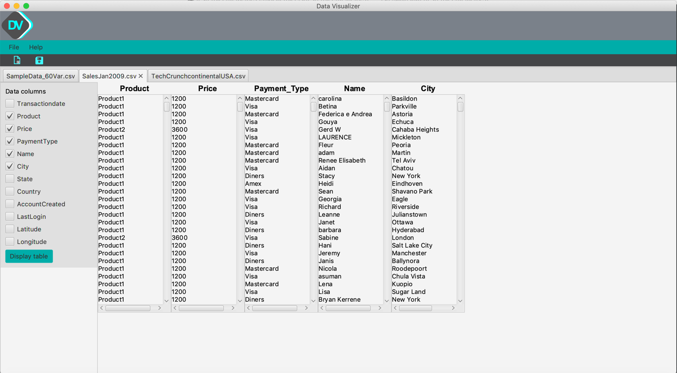

Figure A